Konferans Bildirisi
Makale Başlığınızı Yazınız
Ad Soyad¹*, Ad Soyad²*
¹ Kurumunuz, Orcid ID: https://orcid.org/, e-mail,
² Kurumunuz, Orcid ID: https://orcid.org/, e-mail,
* Sorumlu Yazar: e-mail; mobile phone
(İlk Geliş Tarihi xxxxxx Kabul Tarihi xxxxxx)
3rd International Conference on Design, Research and Development
(RDCONF 2023)
December 13 - 15, 2023
Reference: will be edited by editorial
Özet
Xxxxxxxxxxxxxxxxxxxxxxxxxxxxxxxxxxxxxxxxxxxxxxxxxxxxxxxxxxxxxxxxxxxxxxxxxxxxxxxxxxxxxxxxxxxxxxxxxxxxxxxxxxxxxxxxxxxxxxxx.xxxxxxxxxxxxxxxxxxxxxxxxxxxxxxxxxxxxxxxxxxxxxx.
Anahtar: Xxxx, Xxxx, Xxxx
Conference Article
Write Your Paper Title
Abstract
Xxxxxxxxxxxxxxxxxxxxxxxxxxxxxxxxxxxxxxxxxxxxxxxxxxxxxxxxxxxxxxxxxxxxxxxxxxxxxxxxxxxxxxxxxxxxxxxxxxxxxxxxxxxxxxxxxxxxxxxx.xxxxxxxxxxxxxxxxxxxxxxxxxxxxxxxxxxxxxxxxxxxxxx.
Keywords: Seamless denim, ultrasonic sewing, hot air bonding, hot press bonding

- Giriş
Xxxxxxxxxxxxxxxxxxxxxxxxxxxxxxxxxxxxxxxxxxxxxxxxxxxxxxxxxxxxxxxxxxxxxxxxxxxxxxxxxxxxxxxxxxxxxxxxxxxxxxxxxxxxxx [1].
- Materyal ve Yöntem
Xxxxxxx.
Tablo 1: Deneme Data
Variables | Levels
Fabric composition | 96% cotton - 3% polyester - 1% elastane
Chemical | A, B
Xxxxxxxxxxxxxxxxxxxxxxxxxxxxxxxxxxxxxxxxxxxxxxxxxxxxxxxxxxxxxxxxxxxxxxxxxxxxxxxxxxxxxxxxxxxxxxxxxxxxxxxxxxxxxxxxxxxxxxxxxxxxxxxxxxxxxxxxxxxxxxxxxxxxxx
xxxxxxxxxxxxxxxxxxxxxxxxxxxxxxxxxxxxxxxxxxxxxxxxxxxxxxxxxxxxxxxxxxxxxxxxxxxxxxxxxxxxxxxxxxxxxxxxxxxxx.
  - Alt Başlık
Xxxxxxxxxxxxxxxxxxxxxxxxxxxxxxx.

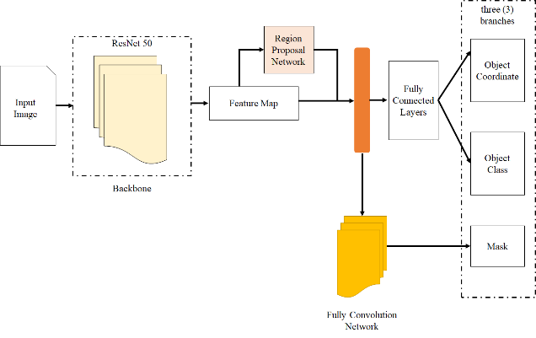
Şekil 1: Xxxxx Xxxxx
- Sonuçlar
Xxxxxxxxxxxxxxxxxxxxxxxxxxxxxxxxxxxxxxxxxxxxxxxxxxxxxxxxxxxxxxxxxxxxxxxxxxxxxxxxxxxxxxxxxxxxxxxxxxxxxxxxxxxxxxxxxxxxxxxxxxxxxxxxxxxxxxxxxxxxxxxxxxxxxxxxxxxxxxxxxxxxxx.
- Tartışma
Xxxxxxxxxxxxxxxxxxxxxxxxxxxxxxxxxxxxxxxxxxxxxxxxxxxxxxxxxxxxxxxxxxxxxxxxxxxxxxxxxxxxxxxxxxxxxxxxxxxx.
- Teşekkür
Xxxxxxxxxxxxxxxxxxxxxxxxx.
Referanslar
- IEEE Stili kullanılacaktır.
- Xxxxxxxx.
- Xxxxxxxxxxxx.

